CSA1708-ARTIFICIAL INTELLIGENCE
LAB EXPERIMENTS
Program 27 : Prolog Program to Implement Best First Search
Aim
To find a goal path by expanding the node with the lowest heuristic value.
Algorithm
1. Store graph connections and heuristic values.
2. Add the start path to the open list.
3. Expand the path with the lowest heuristic value.
4. Return the path when the goal is selected.
Program
edge(start,left).
edge(start,right).
edge(left,goal).
edge(right,goal).
heuristic(start,3).
heuristic(left,2).
heuristic(right,1).
heuristic(goal,0).
best_first(S, G, P) :-
heuristic(S, H), search([H-[S]], G, R), reverse(R, P).
search([_-[G|P]|_], G, [G|P]).
search([_-[N|P]|Open], G, R) :-
findall(H-[X,N|P],
(edge(N,X), \+ member(X,[N|P]), heuristic(X,H)), Kids),
append(Open,Kids,All), keysort(All,Sorted),
search(Sorted,G,R).
Sample Input
?- best_first(start, goal, Path).
Program Execution
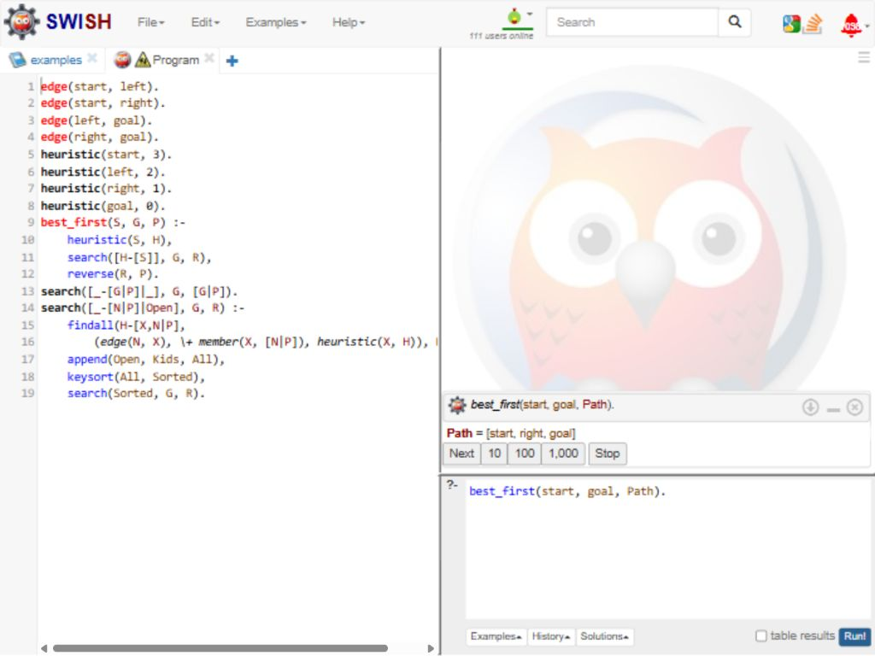
RESULT
Thus, Best-First Search returned the path start -> right -> goal.

